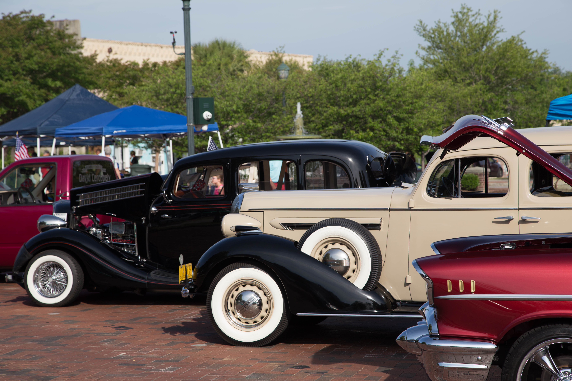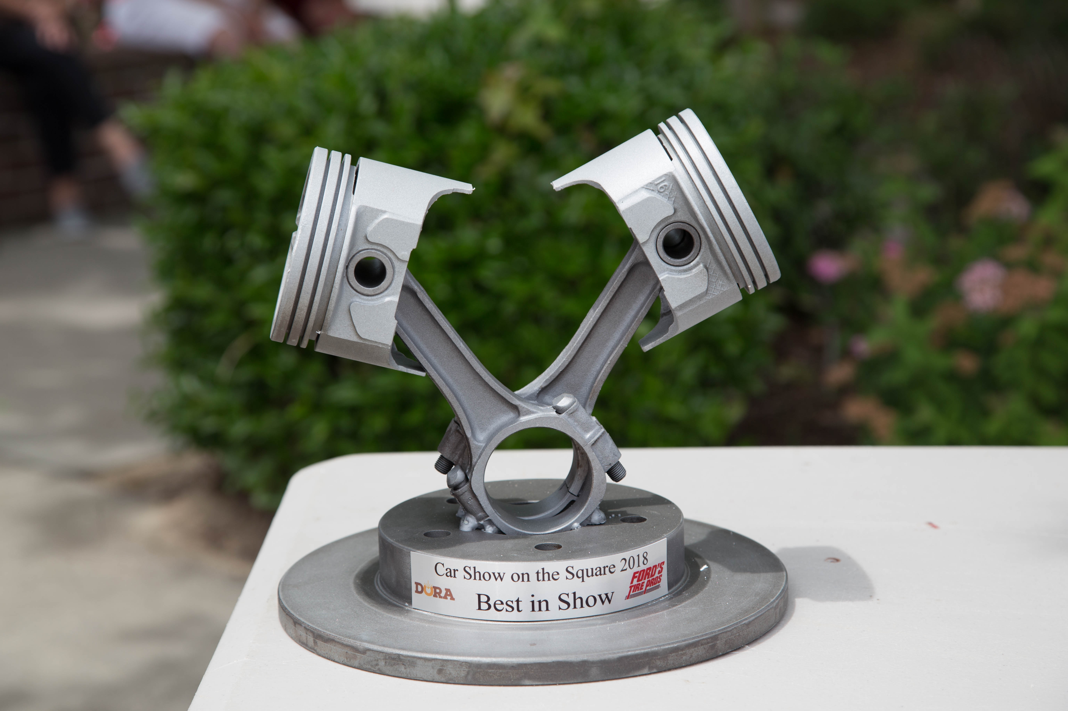

Family Fun

Door prizes

vendors

50/50

Drawing!

Food

trucks!

music

### **Classes Trophies for Top 2 in each class**

Classic Muscle ⚫ Modern Muscle ⚫ Classic Truck ⚫ Modern Truck ⚫ Street Rod

Antique ⚫ Import ⚫ Daily Drive ⚫ 4WD/Off-road ⚫ Motorcycles/Bikes

***Plus Trophies for People’s Choice and Best in Show!***

### **$15 Pre-Registration (By April 26th) ⚫ $20 At Show**

Make Checks Payable to **DORA**. Mailing address **P.O. Box 808, Orangeburg, SC 29116**

Name: _____________________________________________________________________ Phone: _______________________________

Address: ___________________________________________________________________________________________________________

Year: _____________ Make: ___________________ Model: ____________________ Email: _______________________________

Liability: Entrants and participants by execution of this entry form, release and discharge the Downtown Orangeburg Revitalization Association, The City of Orangeburg and anyone else connected with the presentation of the Car Show on the Square from any and all known or unknown damages, injuries that may be suffered by any entrant or participant to his person or property.

Total Enclosed: ___________ Signature of Entrant: ______________________________________________________________

For more information  
*Candice Roberson* (803) 531-6186

www.downtownorangeburg.com

*Ford’s Tire Pros* (803)516-0500

Proceeds from the Car Show on the Square go to support the Downtown Orangeburg Revitalization Association (DORA). As 501(c)3 charitable non-profit organization, DORA promotes the economic development of Downtown Orangeburg.

*Sponsored by*

Saturday, May 2, 2020 10:00 am – 2:00 pm

*Historic Downtown Square, Orangeburg, SC*

Registration 9:00 am – 11:00 am ⚫ Awards Presentation 2:00 pm

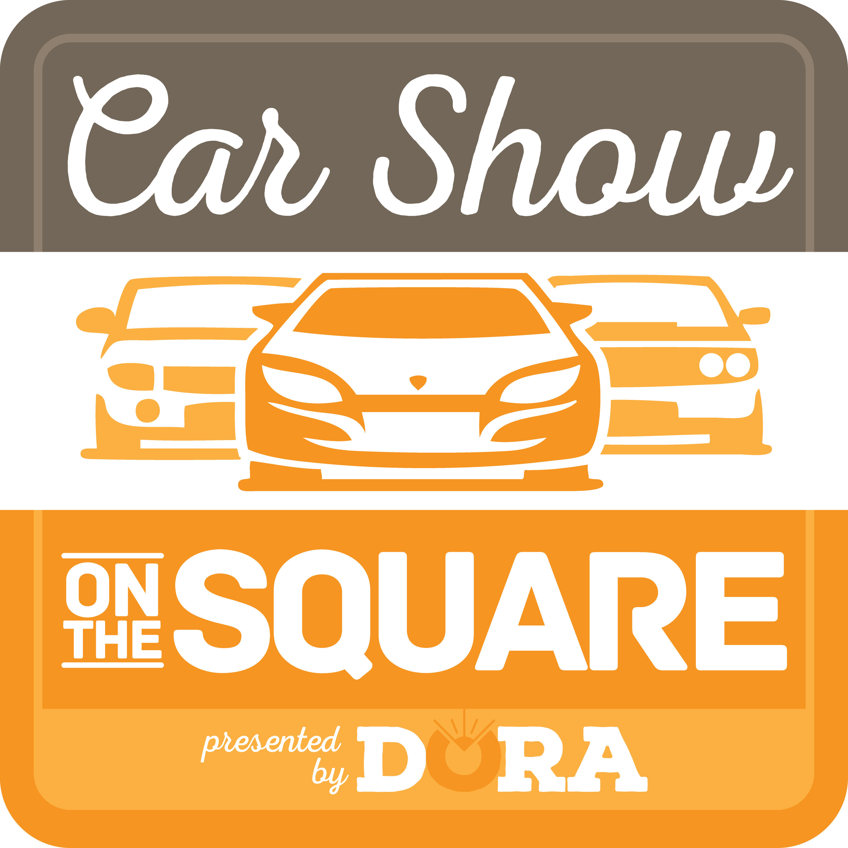

9th Annual