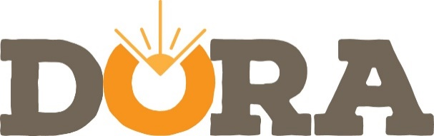
ST. PATRICK’S DAY FESTIVAL
FRIDAY, MARCH 13TH
6 PM – 9 PM
On the Square
Thank you for your interest in being a part of DORA’s St. Patrick’s Day Festival!
The Vendor Fee is $50 for food applicants, $30 for retail vendors and $10 for non-profits. Vendors are required to have a current City of Orangeburg Business License. DORA Partnership Members are encouraged to come out to the festival, or to have sidewalk sales at their businesses during the festival. As always, DORA Partnership Members are welcome at all DORA events, free-of-charge. All vendors must supply their own tents, tables, chairs, extension cords, etc. Vendors are required to be set up and ready to sell 30 minutes before the start of the festival.
Business Name: ________________________________________________________________________
Main Contact: ________________________________ Email: __________________________________
Business Address: ______________________________________________________________________
Vendor Type: DORA Partnership Member $0 General Retail Vendor $30
Food Vendor $50 Non-Profit $10
Business Description
_____________________________________________________________________________________
_____________________________________________________________________________________
_____________________________________________________________________________________
I confirm that I, my representatives, employees and agents, agree to protect and hold Downtown Orangeburg Revitalization Association harmless from any responsibility, personal liability, claims, losses or damages arising out of, or in conjunction with, my participation in the festival. As a vendor/participant in the St. Patrick’s Day Festival, I assume full responsibility for any booth and/or space utilized by me, my employees and my agents; and I accept full responsibility for the quality and condition of any products offered and sold by me, my employees and my agents.
DORA will provide publicity for the St. Patrick’s Day Festival. As such, DORA staff reserves the right to take photos of vendors and vendors’ products for promotion of the event. Promotion includes, but is not limited to: advertisements, press releases, promotional and publicity publications and websites.
By submitting your application, you accept the above conditions and implicitly hold the Downtown Orangeburg Revitalization, its staff, and the City of Orangeburg harmless from any legal actions against these entities. Vendors participate at the sole discretion of DORA.

Signature_________________________________________________________ Date_______________

